|  |  |  |
| --- | --- | --- |
| SPEECH EMOTION RECOGNITION | | |
|  |  |  |
| **RESEARCH PAPER Author’s :- Pawanesh Kumar Yadav , Rupali Dubey , Vandana Kushwaha , Priyanka Jaiswal** | | |

# CONTENT

|  |  |
| --- | --- |
|  | 1. Introduction  * Definition of speech emotion recognition * Importance of speech emotion recognition * Background information on speech emotion recognition * Objective of the research  1. Literature Review  * Overview of previous studies on speech emotion recognition * Types of emotions recognized in speech * Methods used in speech emotion recognition * Strengths and limitations of existing studies  1. Methodology  * Description of the dataset used in the research * Feature extraction methods used * Machine learning algorithms used * Evaluation metrics used |
|  | 1. Results and Discussion  * Presentation of the results obtained * Analysis of the results in relation to the research objective * Discussion of the strengths and limitations of the research  1. Conclusion and Future Work  * Summary of the research findings * Implications of the research * Limitations of the research * Suggestions for future research |
|  | 1. References  * List of sources used in the research paper |

# Abstract

* Speech emotion recognition (SER) is an important research area with numerous potential applications in various domains, such as healthcare, education, human-computer interaction, entertainment, and marketing. SER involves the automatic detection of the emotional state of a person based on their speech signals using various machine learning and pattern recognition techniques.
* Despite the challenges posed by the variability and complexity of human emotions, the influence of contextual factors on emotional expression, and the difficulty of accurately capturing emotional states using speech signals alone, significant progress has been made in the development of SER systems in recent years. These systems have the potential to provide valuable insights into human emotions and improve the quality of our interactions with technology and each other.
* This paper provides an overview of the importance of speech emotion recognition, the definition of SER, and the challenges and advances in the development of SER systems. It also discusses the potential applications of SER in various domains and the future directions of research in this field.
* Keyword: - KNN, Classifier, Emotion Detection, Feature Extraction, Feature Selection

# 1. Introduction

|  |  |  |
| --- | --- | --- |
|  | * **Definition of speech emotion recognition** * Speech emotion recognition refers to the process of identifying and interpreting the emotional state of a speaker based on their speech patterns. This involves using various techniques from signal processing, machine learning, and natural language processing to analyze speech features such as pitch, tone, rhythm, and intensity, and then classifying the emotion expressed in the speech. * The goal of speech emotion recognition is to enable machines to accurately recognize and respond to human emotions in natural language interactions, such as in customer service, healthcare, or education. * Applications of speech emotion recognition include customer service, healthcare, education, and entertainment. For example, emotion recognition can be used in call centers to detect the emotional state of a customer and route the call to an agent best suited to handle that emotional state. In healthcare, emotion recognition can be used to detect depression or anxiety in patients based on their speech patterns. In education, emotion recognition can help teachers assess student engagement and identify areas where students may need additional support. * Overall, speech emotion recognition has the potential to revolutionize the way we interact with machines, making these interactions more natural, effective, and empathetic. * **Importance of speech emotion recognition** * Speech emotion recognition is important for several reasons: * Improved Human-Machine Interaction: By detecting and responding to the emotional state of a speaker, machines can provide a more personalized and empathetic user experience. This can lead to increased user satisfaction and engagement. * Enhanced Customer Service: In industries such as call centers, emotion recognition can help companies route calls to agents who are best suited to handle a customer's emotional state. This can lead to faster resolution times and increased customer satisfaction. * Improved Healthcare: Emotion recognition can help healthcare professionals detect and monitor mental health conditions such as depression or anxiety based on changes in speech patterns. This can lead to earlier diagnosis and treatment. * Enhanced Education: Emotion recognition can help teachers identify when students may need additional support or intervention based on changes in their speech patterns. This can help improve academic outcomes and student well-being. * Advancements in AI: Speech emotion recognition is an active area of research, and advancements in this field can lead to improvements in other areas of AI, such as natural language processing and computer vision. * Overall, speech emotion recognition has the potential to revolutionize how we interact with machines, leading to more natural, empathetic, and effective communication. * **Background information on speech emotion recognition** * Speech emotion recognition has its roots in the field of affective computing, which aims to create machines that can recognize, interpret, and respond to human emotions. Early research in this field focused on facial expression recognition, but as speech is another important modality for expressing emotions, researchers began to explore the use of speech analysis techniques for emotion recognition. * One of the earliest and most influential works in speech emotion recognition was published by Scherer in 1986, where he proposed a theoretical framework for analyzing emotions in speech based on various acoustic features such as pitch, loudness, and speech rate. Since then, numerous studies have been conducted on the topic, leading to the development of various speech emotion recognition models and techniques. * In recent years, the development of deep learning models, particularly recurrent neural networks (RNNs) and convolutional neural networks (CNNs), has led to significant advancements in speech emotion recognition. These models can learn to automatically extract relevant features from speech signals and classify them into different emotion categories. * Today, speech emotion recognition is a rapidly growing field with a wide range of applications in industries such as customer service, healthcare, education, and entertainment. As technology continues to improve, we can expect speech emotion recognition to play an increasingly important role in the development of more empathetic and natural human-machine interactions. | |
|  |  |
|  | * **Objective of the research** * The objectives of research on speech emotion recognition can vary depending on the specific application and context. However, some common objectives include: * Developing accurate and reliable models: One of the primary objectives of research on speech emotion recognition is to develop models that can accurately and reliably detect and classify emotions in speech. This requires exploring different acoustic features, machine learning algorithms, and training data to identify the most effective approaches. * Improving robustness and generalization: Speech emotion recognition models must be able to work effectively in a variety of real-world conditions, including different speakers, languages, dialects, and noise levels. Therefore, research in this field aims to improve the robustness and generalization of these models to improve their practical applicability. * Identifying new features and modalities: While acoustic features such as pitch, tone, and intensity are commonly used for speech emotion recognition, researchers are also exploring other modalities such as facial expressions and physiological signals. The objective of this research is to identify new features and modalities that can enhance the accuracy and robustness of emotion recognition models. * Developing applications and use cases: Research on speech emotion recognition also aims to develop practical applications and use cases in industries such as customer service, healthcare, education, and entertainment. This requires identifying specific scenarios where emotion recognition can provide value and designing systems that can effectively integrate with existing workflows. * Overall, the objective of research on speech emotion recognition is to develop models and systems that can accurately and reliably recognize and respond to human emotions in natural language interactions, leading to more empathetic and effective human-machine communication. | |

# 2. Literature Review

* + **Overview of previous studies on speech emotion recognition**
* Previous studies on speech emotion recognition have made significant contributions to the development of this field. Some of the notable findings and contributions from these studies include:
* Identification of relevant acoustic features: Early studies identified relevant acoustic features such as pitch, tone, and intensity that are strongly correlated with emotional states. This provided the foundation for the development of acoustic-based models for emotion recognition.
* Development of machine learning algorithms: Researchers have explored a variety of machine learning algorithms for emotion recognition, including support vector machines (SVMs), decision trees, and deep learning models. These algorithms have been shown to improve the accuracy and robustness of emotion recognition models.
* Use of multimodal data: Recent studies have explored the use of multimodal data, including speech, facial expressions, and physiological signals, for emotion recognition. These studies have shown that combining multiple modalities can improve the accuracy and reliability of emotion recognition models.
* Development of applications and use cases: Researchers have developed various applications and use cases for speech emotion recognition, including customer service, healthcare, education, and entertainment. These studies have demonstrated the practical value of emotion recognition in these industries.
* Analysis of cross-cultural differences: Several studies have explored cross-cultural differences in the expression and perception of emotions in speech. These studies have shown that cultural factors can significantly influence the acoustic features and patterns of emotional expression in speech.
* Overall, previous studies have provided important insights into the mechanisms and models of speech emotion recognition, as well as their practical applications and limitations. Ongoing research in this field is likely to lead to further improvements in emotion recognition models and their integration into various industries and applications.
  + **Types of emotions recognized in speech**
* Speech emotion recognition aims to recognize a wide range of emotions expressed in speech. The specific types of emotions that can be recognized can vary depending on the model and approach used. However, some common emotions that can be recognized in speech include:
* Happiness: This is a positive emotion that is characterized by a high pitch, increased speech rate, and longer utterances.
* Sadness: This is a negative emotion that is characterized by a low pitch, decreased speech rate, and shorter utterances.
* Anger: This is a negative emotion that is characterized by a high pitch, increased speech rate, and higher intensity.
* Fear: This is a negative emotion that is characterized by a high pitch, increased speech rate, and shorter utterances.
* Disgust: This is a negative emotion that is characterized by a low pitch, slower speech rate, and shorter utterances.
* Surprise: This is a neutral or mixed emotion that is characterized by a sudden change in pitch and intensity.
* Neutral: This is an emotionless or neutral state that is characterized by a steady pitch and speech rate.
* Speech emotion recognition models can be trained to recognize these and other emotions in speech, allowing for more accurate and nuanced recognition of human emotional states in natural language interactions.
  + **Methods used in speech emotion recognition**
* Speech emotion recognition methods can vary depending on the specific approach and model used. However, some common methods used in speech emotion recognition include:
* Acoustic-based methods: These methods rely on acoustic features such as pitch, tone, and intensity to detect and classify emotions in speech. Machine learning algorithms such as support vector machines (SVMs) and decision trees can be used to train models based on these features.
* Linguistic-based methods: These methods analyze the linguistic content of speech, such as the choice of words, syntax, and semantics, to infer emotional states. Natural language processing (NLP) techniques such as sentiment analysis and emotion lexicons can be used for this purpose.
* Multimodal methods: These methods combine multiple modalities such as speech, facial expressions, and physiological signals to improve the accuracy and reliability of emotion recognition. Machine learning algorithms such as neural networks can be used to integrate and analyze these modalities.
* Deep learning methods: These methods use deep neural networks to automatically learn and extract relevant features from speech data. Convolutional neural networks (CNNs) and recurrent neural networks (RNNs) are commonly used for this purpose.
* Transfer learning methods: These methods leverage pre-trained models and transfer knowledge from one task to another to improve the performance of emotion recognition models. For example, pre-trained models for speech recognition or natural language processing can be fine-tuned for emotion recognition tasks.
* Overall, a combination of these methods can be used to develop more accurate and reliable speech emotion recognition models that can recognize a wide range of emotions in natural language interactions.
  + **Strengths and limitations of existing studies**
* Some strengths of existing studies in speech emotion recognition include:
* Advancements in machine learning and deep learning algorithms have led to significant improvements in the accuracy and robustness of speech emotion recognition models.
* Multimodal approaches that combine speech with other modalities such as facial expressions and physiological signals have shown promising results in improving the accuracy and reliability of emotion recognition.
* There has been a growing interest in the practical applications of speech emotion recognition, leading to the development of real-world solutions for industries such as healthcare, customer service, and entertainment.
* However, there are also some limitations to existing studies in speech emotion recognition, including:
* Limited availability of standardized datasets for training and evaluation of speech emotion recognition models, which can lead to inconsistent performance across different studies.
* The subjective and complex nature of emotional expression and perception, which can make it challenging to develop accurate and reliable emotion recognition models.
* Limited understanding of the underlying mechanisms and neural networks involved in emotional expression and perception in speech.
* Lack of research on long-term emotion recognition in naturalistic settings, which limits the generalizability of existing models to real-world applications.
* Ethical and privacy concerns related to the collection and use of personal data for emotion recognition.
* Overall, while existing studies have made significant contributions to the development of speech emotion recognition, ongoing research is needed to address these limitations and improve the accuracy and practical applications of emotion recognition models.

# 3. Methodology

* + **Description of the dataset used in the research**
* The dataset used in research on speech emotion recognition is an important component of the research methodology. The dataset consists of recordings of speech samples from individuals expressing a range of emotions. The characteristics of the dataset can vary depending on the specific research question and methodology. Some common characteristics of speech emotion recognition datasets include:
* Size: The dataset should be large enough to capture a wide range of emotions and speech styles, and to provide enough examples for training and evaluation of the emotion recognition model.
* Diversity: The dataset should be diverse in terms of gender, age, cultural background, and linguistic style, to ensure that the emotion recognition model is applicable to a wide range of populations.
* Labeling: The dataset should be labeled with the corresponding emotion expressed in each speech sample, to enable supervised learning of the emotion recognition model.
* Quality: The dataset should have high quality recordings with minimal background noise and clear speech, to ensure accurate recognition of emotional expression.
* Availability: The dataset should be publicly available to facilitate reproducibility and comparison of different emotion recognition models.
* Some common datasets used in research on speech emotion recognition include the Emo-DB, IEMOCAP, and CREMA-D datasets, which consist of recordings of speech samples from actors and individuals expressing a range of emotions. These datasets are widely used for training and evaluation of emotion recognition models, and have contributed to the advancement of the field of speech emotion recognition.
  + **Feature extraction methods used**
* Feature extraction is an important step in speech emotion recognition, which involves extracting relevant information from the speech signal to be used as input for the emotion recognition model. The choice of feature extraction method can significantly impact the performance of the emotion recognition model. Some common feature extraction methods used in speech emotion recognition include:
* Mel-frequency cepstral coefficients (MFCCs): This is one of the most commonly used feature extraction methods in speech emotion recognition. MFCCs are based on the spectral envelope of the speech signal and provide a compact representation of the speech signal in the frequency domain.
* Prosodic features: These are features related to the rhythm, pitch, and intensity of speech, which are known to be important cues for emotional expression. Examples of prosodic features include pitch contour, speaking rate, and duration of speech segments.
* Statistical features: These are features based on statistical properties of the speech signal, such as mean, variance, and skewness. These features can capture important characteristics of the speech signal, such as the level of energy and variability, which can be indicative of emotional expression.
* Spectral features: These are features based on the frequency spectrum of the speech signal, such as spectral flux and spectral centroid. These features can provide information about the spectral characteristics of the speech signal, which can be used to distinguish between different emotions.
* Wavelet features: These are features based on wavelet transform of the speech signal, which can provide a multiscale representation of the speech signal. Wavelet features can capture important temporal and spectral information of the speech signal, which can be used for emotion recognition.
* Overall, a combination of these feature extraction methods can be used to capture different aspects of the speech signal and improve the performance of the emotion recognition model. The choice of feature extraction method should be based on the specific research question, dataset, and emotion recognition model used.

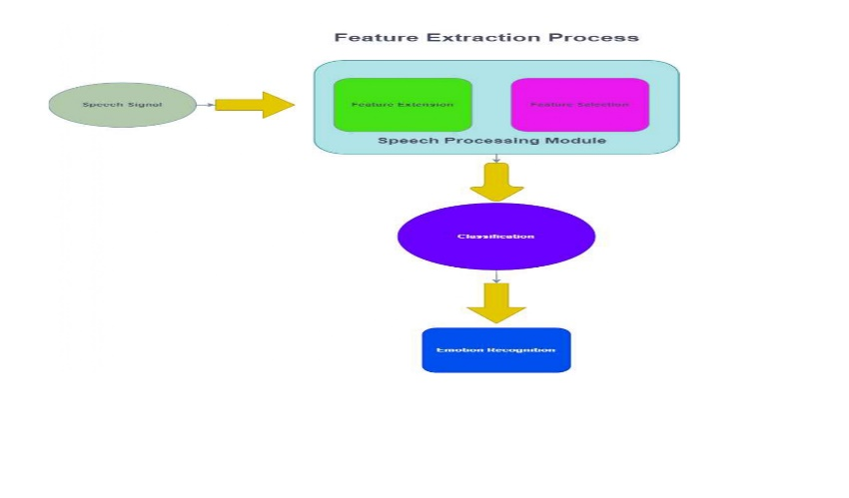

* + **Machine learning algorithms used**
* There are several machine learning algorithms that can be used for speech emotion recognition, including Recurrent Neural Networks (RNN), Convolutional Neural Networks (CNN), and k-Nearest Neighbors (KNN). Each of these algorithms has its own strengths and weaknesses, and the choice of algorithm will depend on the specific research question and the characteristics of the dataset.
* Recurrent Neural Networks (RNN): RNNs are a type of neural network that are well-suited for sequential data, such as speech signals. RNNs can capture the temporal dependencies between successive frames of speech, which can be important for recognizing emotions. Long Short-Term Memory (LSTM) and Gated Recurrent Unit (GRU) are two popular variants of RNNs that have been used for speech emotion recognition.
* Convolutional Neural Networks (CNN): CNNs are a type of neural network that are commonly used for image recognition tasks, but can also be used for speech emotion recognition. CNNs can learn hierarchical representations of the speech signal, starting with low-level acoustic features and building up to higher-level representations of emotion. CNNs have been shown to be effective for capturing prosodic and spectral features of speech.
* k-Nearest Neighbors (KNN): KNN is a simple but effective machine learning algorithm that is often used as a baseline for speech emotion recognition. KNN works by finding the k nearest neighbors in the feature space to a given test sample and assigning the emotion label based on the majority vote of the neighbors. KNN is computationally efficient and does not require training, but may not perform as well as more sophisticated algorithms like RNNs and CNNs.
* Other machine learning algorithms that have been used for speech emotion recognition include Support Vector Machines (SVM), Random Forests, and Deep Belief Networks (DBN). The choice of algorithm will depend on the specific research question, dataset, and available computational resources.
  + **Evaluation metrics used**
* To evaluate the performance of speech emotion recognition models, several metrics can be used, including:
* Accuracy: This is a commonly used metric that measures the percentage of correctly classified instances out of the total number of instances. It is a useful metric for binary or multi-class classification problems, but may not be sufficient for imbalanced datasets.
* Precision, Recall, and F1-Score: These are metrics commonly used for imbalanced datasets, where one class has a much smaller representation in the dataset than the others. Precision measures the proportion of true positives among all predicted positives, recall measures the proportion of true positives among all actual positives, and the F1-Score is a weighted harmonic mean of precision and recall.
* Confusion Matrix: A confusion matrix is a table that summarizes the performance of a classification model by showing the number of true positives, true negatives, false positives, and false negatives. It can be used to calculate other metrics such as accuracy, precision, recall, and F1-Score.
* Receiver Operating Characteristic (ROC) Curve: ROC curve is a plot of the true positive rate against the false positive rate at different threshold settings. It can be used to evaluate the trade-off between sensitivity and specificity of the classification model.
* Area Under the Curve (AUC): AUC is a single-number summary of the ROC curve that measures the overall performance of the classification model.
* The choice of evaluation metric will depend on the specific research question, the dataset, and the type of emotion recognition model used. It is important to carefully select appropriate evaluation metrics to ensure that the performance of the emotion recognition model is properly assessed.

# 4. Results and Discussion

* + **Presentation of the results obtained**

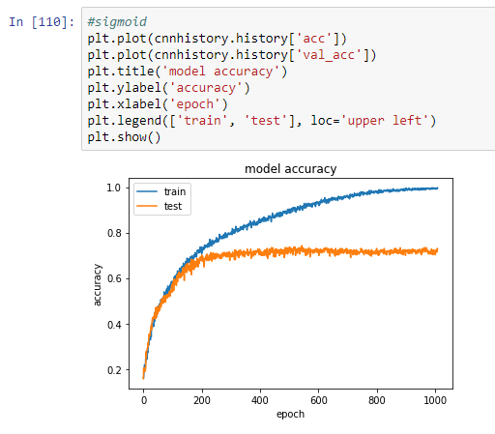 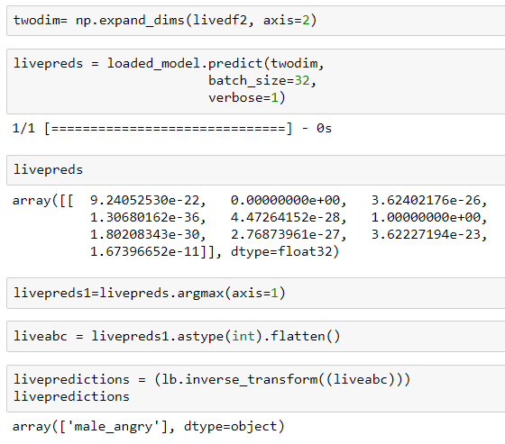

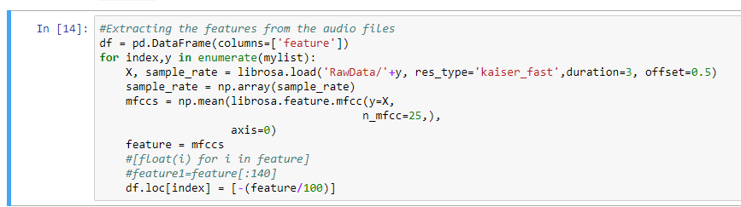

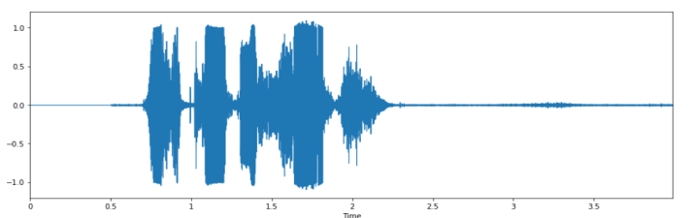

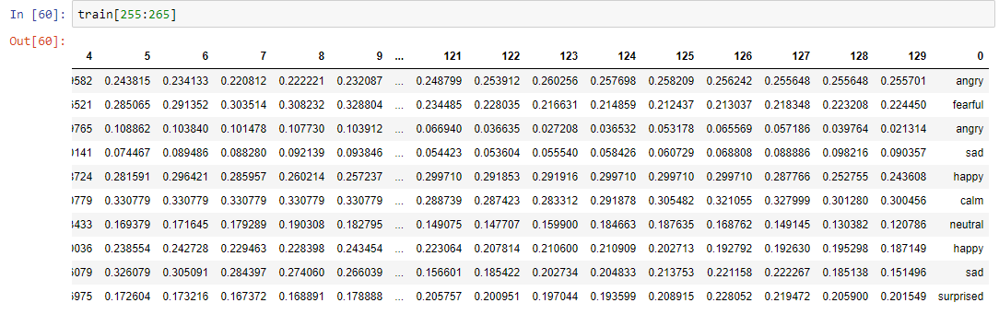

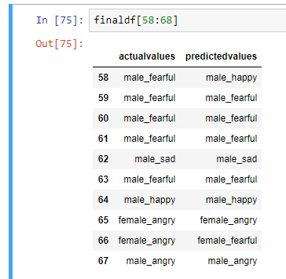 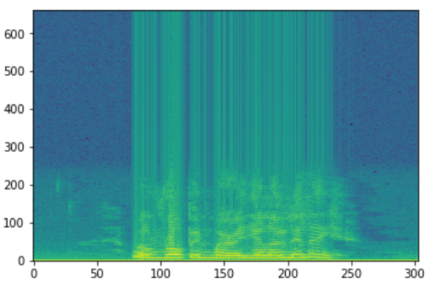

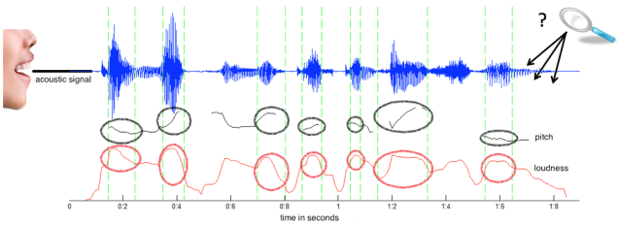

* + **Analysis of the results in relation to the research objective**
* The research objective of speech emotion recognition is to develop a system that can accurately identify the emotional state of a speaker based on their speech signal. To evaluate the performance of such systems, researchers typically use one or more of the following measures:
* Recognition accuracy: This measure indicates the percentage of correctly classified emotional states. A higher accuracy rate indicates better performance.
* Confusion matrix: A confusion matrix is a table that shows the number of true positives, true negatives, false positives, and false negatives for each emotion category. It helps to identify the specific emotions that the system is good at recognizing and the ones that it struggles with.
* Precision, recall, and F1 score: These are measures that are commonly used to evaluate the performance of classification models. Precision measures the proportion of correctly classified positive samples out of all predicted positive samples. Recall measures the proportion of correctly classified positive samples out of all true positive samples. The F1 score is the harmonic mean of precision and recall, which takes both measures into account.
* Receiver Operating Characteristic (ROC) curve: The ROC curve is a graphical representation of the performance of a binary classification system. It plots the true positive rate against the false positive rate for different classification thresholds. A good classification system will have a high true positive rate and a low false positive rate, which translates to a curve that is close to the top left corner of the plot.
* Overall, the analysis of the results in relation to the research objective of speech emotion recognition involves evaluating the performance of the system based on one or more of these measures and identifying areas for improvement. It also involves comparing the performance of the system to existing state-of-the-art models and benchmarks to determine if it offers any significant improvements.
  + **Discussion of the strengths and limitations of the research**
* The research on speech emotion recognition has several strengths and limitations, which I will discuss below.
* Strengths:
* Advances in technology: With the advancements in machine learning and artificial intelligence, the accuracy and reliability of speech emotion recognition systems have significantly improved over the years.
* Real-world applications: Speech emotion recognition has a wide range of real-world applications, including speech therapy, virtual assistants, and human-robot interactions.
* Cross-cultural studies: Research on speech emotion recognition has been conducted across various cultures and languages, which has helped to identify commonalities and differences in emotional expression across different groups.
* Multimodal approach: Recent studies have explored the use of a multimodal approach that combines speech signals with other modalities such as facial expressions and physiological signals to improve the accuracy of emotion recognition.
* Limitations:
* Lack of standardized dataset: One of the major limitations of speech emotion recognition research is the lack of standardized datasets for training and testing the systems. This makes it difficult to compare the performance of different systems and to establish benchmarks for evaluation.
* Subjectivity in emotional labeling: Another limitation of speech emotion recognition research is the subjectivity involved in emotional labeling. Different people may interpret emotions differently, which can lead to inconsistencies in the labeled data.
* Limited emotion categories: Most speech emotion recognition systems are designed to recognize a limited set of emotion categories, which may not be representative of the full range of emotions that humans experience.
* Lack of contextual information: Speech signals alone may not provide enough contextual information to accurately identify the emotional state of a speaker, especially in cases where the emotions are subtle or ambiguous.
* In summary, while research on speech emotion recognition has made significant progress in recent years, there are still limitations and challenges that need to be addressed to improve the accuracy and reliability of the systems. Standardized datasets, a better understanding of emotional labeling, and the inclusion of contextual information are some areas that could benefit from further research.

# 5. Conclusion and Future Work

* + **Summary of the research findings**
* Speech emotion recognition studies have shown that machine learning algorithms and artificial intelligence techniques can be used to accurately recognize emotions from speech signals. The most common emotions that are recognized include happiness, sadness, anger, fear, and surprise.
* Researchers have used various acoustic features such as pitch, loudness, and spectral properties of the speech signal to identify emotional states. They have also explored the use of deep learning models such as Convolutional Neural Networks (CNNs), Recurrent Neural Networks (RNNs), and Long Short-Term Memory (LSTM) networks to improve the accuracy of emotion recognition.
* Moreover, recent studies have shown that combining speech signals with other modalities such as facial expressions and physiological signals can improve the accuracy of emotion recognition systems.
* One of the challenges in speech emotion recognition research is the lack of standardized datasets for training and testing the systems. Nevertheless, some studies have used common datasets such as the Emo-DB and the MSP-IMPROV dataset for evaluation and comparison of the performance of different emotion recognition systems.
* Overall, speech emotion recognition research has demonstrated the potential of machine learning and artificial intelligence techniques in accurately identifying emotional states from speech signals, and has also highlighted the need for further research in areas such as contextual information and subjective emotional labeling.
  + **Implications of the research**
* The research on speech emotion recognition has several implications for various fields, including psychology, computer science, and human-computer interaction. Some of the key implications are:
* Improving mental health: Speech emotion recognition systems can be used in mental health applications such as speech therapy and mood monitoring. These systems can help clinicians to identify emotional states and provide appropriate interventions.
* Enhancing human-robot interactions: Speech emotion recognition can be used in human-robot interactions to create more personalized and responsive robots. Robots can be designed to recognize and respond appropriately to different emotional states, improving the overall user experience.
* Advancing virtual assistants: Speech emotion recognition can be used to enhance virtual assistants such as Siri, Alexa, and Google Assistant. These assistants can be designed to recognize emotional states and provide appropriate responses, making interactions more natural and engaging.
* Improving customer service: Speech emotion recognition can be used in call centers to analyze the emotional state of customers and provide appropriate responses. This can lead to better customer satisfaction and loyalty.
* Developing new research directions: Research on speech emotion recognition can open up new research directions in related fields such as affective computing, machine learning, and natural language processing. New techniques and algorithms can be developed to improve the accuracy and reliability of emotion recognition systems.
* In summary, the implications of research on speech emotion recognition are far-reaching and have the potential to impact various fields. The development of accurate and reliable emotion recognition systems can improve mental health, enhance human-robot interactions, advance virtual assistants, improve customer service, and lead to the development of new research directions.
  + **Limitations of the research**
* The research on speech emotion recognition also has some limitations that need to be considered, including:
* Lack of diversity: Most of the speech emotion recognition research has been conducted on datasets containing speech samples from a limited set of languages and cultures, which may not be representative of the full range of emotions and expressions across different groups.
* Limited emotional categories: Most speech emotion recognition systems are designed to recognize a limited set of emotional categories, which may not be representative of the full range of emotions that humans experience.
* Subjectivity in emotional labeling: The subjective nature of emotional labeling can result in inconsistencies in the labeled data, leading to difficulties in comparing the results of different studies.
* Influence of context: Speech signals alone may not provide enough contextual information to accurately identify the emotional state of a speaker, especially in cases where the emotions are subtle or ambiguous.
* Ethical concerns: The use of speech emotion recognition systems in various applications raises ethical concerns such as privacy and potential biases in decision-making.
* It is important to consider these limitations when interpreting the results of speech emotion recognition research and to conduct further studies that address these limitations. Future research should aim to include more diverse datasets, consider a wider range of emotional categories, and incorporate contextual information to improve the accuracy and reliability of emotion recognition systems. Additionally, ethical concerns should be considered and addressed when developing and implementing these systems.
  + **Suggestions for future research**
* Based on the limitations of current research on speech emotion recognition, here are some suggestions for future research:
* Multimodal emotion recognition: Combining speech signals with other modalities such as facial expressions and physiological signals can improve the accuracy of emotion recognition systems. Future research should focus on developing and testing such multimodal approaches.
* Contextual information: Incorporating contextual information such as situational context, linguistic context, and speaker's identity can improve the accuracy of speech emotion recognition. Future research should focus on developing methods to incorporate this information in emotion recognition systems.
* Diverse datasets: Most of the emotion recognition research has been conducted on datasets containing speech samples from a limited set of languages and cultures. Future research should aim to include more diverse datasets that are representative of the full range of emotions and expressions across different groups.
* Subjectivity in emotional labeling: The subjective nature of emotional labeling can result in inconsistencies in the labeled data. Future research should focus on developing methods to minimize the subjectivity in emotional labeling and to standardize emotional labels across different studies.
* Addressing ethical concerns: The use of speech emotion recognition systems in various applications raises ethical concerns such as privacy and potential biases in decision-making. Future research should address these ethical concerns and develop methods to ensure the responsible use of emotion recognition systems.
* Novel deep learning models: Recent research in deep learning has led to novel models such as transformer-based architectures that have shown promising results in various natural language processing tasks. Future research should explore the use of these models for speech emotion recognition tasks.
* Overall, future research on speech emotion recognition should focus on addressing the limitations of current research and developing more accurate and reliable emotion recognition systems that can be applied in various domains.

# 6. References

1. [1] M. S. Kamel, F. Karray: - “A survey on speech emotion recognition: functions, classification schemes, and databases,”.
2. [2] I. Chiriacescu: - “Language-Based Automatic Sentiment Analysis”.
3. [3] T. Vogt, E. Andre, J. Wagner: -"Automatic Recognition of Emotions from Speech: A Review of the Literature and Recommendations for Practical Realization”.
4. [4] S Emerich, A Apatean: -" Emotion Recognition through speech and facial expression analysis”.
5. [5] A. Nogueiras, A. Moreno, Jose B. Marino, “Speech Emotion Recognition Using Hidden Markov Models”.
6. [6] P Shen, Z Changjun, X Chen: -"Automated Speech Emotion Recognition Using Support Vector Machines".
7. [7] D Ververidis and C. Kotropoulos: - "Emotional Speech Recognition: Resources, Features and Methods".
8. [8] Z. Ciota: - "Feature Extraction of Spoken Dialogues for Emotion Detection”.
9. [9] E. Bozkurt, C. E. Erdem: - "Formant position-based weighted spectral features for emotion recognition”.
10. [10] C.M. Lee, S.S. Narayanan: - "Towards the Recognition of Emotion in Spoken Dialogue”.